Position Description

Indigenous Cultural Program Manager: Full Time/Part Time

Play a key role in strengthening and deepening Indigenous leadership at Footscray Community Arts.

You’ll coordinate the Indigenous Advisor Group and Elders in Residence at an exciting time as we build a new outdoor performance space grounded in a First Nations First approach.

Support the growth of Indigenous artists through Tarnuk-ut baany, a personal and professional development program facilitating cultural knowledge exchange through creative mentorship, workshops and project seed funding.

Title | Indigenous Cultural Program Manager
Reports To | Artistic Director & Co-CEO
Direct Reports | None
Key Relationships | Elders in Residence & Indigenous Advisory Group, Tarnuk-ut baany artists, Construction partners, Government and non-Government funding partners, Artistic Program Partners, Internal stakeholders and team members, Executive Director & Co-CEO.
Employment Basis | Full Time (37.5 hours per week) or Part Time by negotiation. Footscray Community Arts utilizes a time in lieu policy.
Employment Conditions | Appointed for a fixed term of 2 years from commencement. A six (6) month probation period applies, subject to an employment contract, which sets out all terms and conditions of employment including remuneration and superannuation.  Employment is subject to a National Police Check and Working With Children Check.
Salary | $75,000 per annum full time (or full-time equivalent rate at part-time) + minimum superannuation contribution.
Employment Benefits | - Access to Employee Assistance Program  - Opportunities for professional development  - Positive, socially engaged work culture  - Flexible Working Arrangements including remote work, spread of hours and workplace adjustments including adjustments for accessibility.
Location | The position is based at Footscray Community Arts, 45 Moreland Street, Footscray (centrally located 10 minutes from Melbourne’s CBD.
How to apply and closing date | To apply, answer the following four questions.  - Tell us about your experience working in First Nations contexts.  - What excites you about the Indigenous Cultural Program Manager role?  - What previous roles have you held that best prepare you for working at Footscray Community Arts and why?  - Upload CV or provide a link to your work history on LinkedIn or similar.  You can provide your answers by completing this form or by calling Daniel Santangeli on 03 9362 8816 to have a yarn.  Alternatively, you can submit a cover letter and CV to applications@footscrayarts.com  If you have access requirements to support your application, please let us know. We cannot accept late applications.  Applications close Wed 3 April 2024, end of day.
Who to talk to | Daniel Santangeli– Artistic Director & Co-CEO  phone | 03 9362 8816 or email| applications@footscrayarts.com
Employment Values | The principles that guide our work are curation, custodianship, connectedness and care. We actively champion cultural agency, inclusion and access as we work towards establishing next practice ways of working. We strongly encourage applications from First Nations people, people of colour and from diaspora communities, people with lived experience of Disability, d/Deaf people and people from LGBTQIA+ communities. We are dedicated to developing safe and flexible working environments for our team and are committed to a cultural of continuous improvement, learning and unlearning.
Acknowledgment of Country | We acknowledge that we are on the traditional lands of the Wurundjeri people of the Kulin Nation. We offer our respect to the Elders of these traditional lands, and through them, to all Aboriginal and Torres Strait Islander people.

Position Description: Indigenous Cultural Program Manager

Summary

This key leadership role will support Indigenous cultural practice at Footscray Community Arts – strengthening and deepening our First Nations First approach as a leading arts precinct grounded in community-engaged practice.

This role will be responsible for coordinating the Indigenous Advisory Group and Elders in Residence: a group of respected senior cultural practitioners who offer guidance and expertise encompassing curation, cultural protocol and organizational cultural competency. The Indigenous Advisory Group will further play a key role in providing guidance as we design and construct a new outdoor performance space due for completion in late 2025; and the Indigenous Cultural Program Manager will also be key in coordinating this group around this project.

The Indigenous Cultural Program Manager will be responsible for the delivery of Tarnuk-ut baany: taking its name from the BoonWurrung phrase ‘wooden vessels holding water’ – meaning an invitation to share food, sit around and tell stories. This program supports the growth of emerging and mid-career Indigenous artists through cultural knowledge exchange, creative mentorship, workshops and project seed funding.

As part of this role, you’ll have access to professional development opportunities to support your growth within the role and your future aspirations.

Working Culture and Attributes for Success

We are looking for someone who is:
- Enthusiastic about contemporary Indigenous arts practice: Through your role, you’ll enable emerging and mid-career Indigenous artists to further their practice and develop new work in a culturally grounded learning environment.
- Experienced in working in First Nations contexts: You’ll bring a strength-based approach that prioritizes self-determination informed by a deep understanding of Indigenous community’s history, values and ways of working.
- Committed to learning and listening: This is reflected in how you work with the Indigenous Advisory Group and Elders as well as in the spaces you create for artists, staff and stakeholders.
- Has a sophisticated level of professional judgement: a considered leader, who is able to comprehend complex issues and navigate them with professionalism.
- Organised & a proactive communicator: You’ll be able to set-up and coordinate systems and communication processes that support culturally safe ways of working within your portfolio.

Core Duties and Deliverables

Focus Area | Description
Indigenous Advisory Group and Elders in Residence: Coordination and Liaison | - Coordinate and attend regular Indigenous Advisory Group (IAG) meetings, including setting dates and sending invitations, and support the group by recording and distributing meeting minutes and related documentation.  - Develop systems and frameworks that support the functioning of the IAG and Elders in Residence in line with the IAG Terms of Reference and Board Charter  - Support Board, Co-CEOs, staff, artists and external stakeholders to interface with IAG as required across a range of projects  - Provide support to Elders in Residence and IAG members when on site and at Footscray Community Arts events  - From time to time, provide end-to-end coordination of special projects or initiatives that further the goals of the Indigenous Advisory Group
- Responsible for developing and coordinating an annual artist development program for up to five emerging and mid-career Indigenous artists including:
  - designing program with guidance from IAG
  - coordinating selection process and liaising with participants
  - coordinating program elements (eg mentorships, workshops)
  - project budget coordination
  - Liasing with Venue Operations and Marketing Teams internally
- Research and apply for funding opportunities to support the future delivery of Indigenous artist development programs and the Indigenous Cultural Program.
- Contribute to the maintenance of funding agreements, risk and asset registers, contracting systems, internal and external reporting requirements in association with the Indigenous Cultural Program.
- Evaluate and report on program outcomes

Team Culture | - Model a positive, culturally safe and generative team culture with support and guidance from the Artistic Director.  - Work with a high level of transparency and integrity, including creating a culture of open and constructive feedback.
Compliance and Continuous Improvement | - Develop new and update existing guidance documents, work instructions and templates as relevant to scope of role.  - Ensure understanding of and adherence to FCA’s policies and procedures amongst team.  - Escalate issues appropriately and seek support as required.  - Take personal responsibility for adherence to OH&S, safety and work policies and procedures. Model this for team.
Operational Planning & Delivery | - Support the Executive team to implement the Strategic Plan.  - Work collaboratively to ensure cross-department collaboration to present artistic outcomes to a high level.  - Contribute to the development and implementation of operational plans to deliver on the goals and outcomes of Footscray Community Arts’ Strategic Plan as it relates to the Indigenous Cultural Program.  - Contribute to implementation of Footscray Community Arts’ Disability and Inclusion Action Plan.  - Proactively identify operational risks and escalate to Executive team for collaborative solution finding as required.

Selection Criteria

Essential
- Strong social justice frameworks and alignment with our core values of Cultural Agency, Next Practice and Access & Inclusion
- Experience working in First Nations contexts
- Demonstrated experience and passion for producing and administering artistic projects and outcomes from inception to acquittal.

Recruitment Process
The recruitment process includes:
- Apply: complete this form or by calling Daniel Santangeli on 03 9362 8816 to have a yarn.
- One interview
- Interview panel consisting of management staff and an Indigenous Advisory Group member
- Reference checks

Applications close Wed 3 April 2024, end of day.

About Us

Footscray Community Arts values all communities as makers of culture.

For 50 years, Footscray Community Arts has been recognised for exemplary practice in community arts and cultural development. Our year-round programs have fostered generations of contemporary arts practitioners. We are the largest arts employer in Melbourne’s western suburbs – situated 6km west from Melbourne’s CBD in a region comprising of six local government authorities with a population representing 130 distinct ethnicities speaking over 150 languages.

As an arts precinct, and through development programs and presentations, we actively work to create a place that is vibrant, culturally safe and artistically ambitious. This is led by communities whose cultural agency has not historically been seen, centred or prioritised by the creative industries.

We centre and prioritise artists and artsworkers who are First Nations, people of colour, people from diaspora communities, and people who have lived experience of Disability, d/Deaf people and people from the LGBTIQA+ community.

We do this work with and for communities, to support and sustain artistic relevance and to influence a shift in who art is for and why it is important, generating social and cultural impact locally and globally.

Our Programs
Our programs and initiatives are long-term, high-impact and underpinned by our principles of curation, custodianship, connectedness and care. The way we work is built on models of community and cultural development practice, collaborative leadership and, always, with First Nations ﬁrst.
Read our Annual Report for more information about our programs.
Delivery Area | Description
Major Projects and Commissions | - These ambitious projects of scale profile artists from the communities we centre, generating visitation and audience growth.  - Artist-led and supported by our sophisticated infrastructure and valuable partnerships, these are pivotal moments to profile ideas, conversations, and ground-breaking artistic practice.
Artist and Industry Development | - Our immersive artist and industry development programs respond to the needs of artists and communities. We provide studio space and support for creative development, facilitate conversations, and build capacity through workshops and mentorship. These impactful programs work with artists over long periods of time, generating industry pathways and connections.  - Through these programs we generate sector change by enhancing the visibility of our focus communities and promote equity and cultural safety in the Australian arts industry.
Public Program | - Built on a belief that the arts should be for everyone, these programs invite audiences to engage with accessible, fun, challenging and exciting creative experiences. This year-round suite of presentation-based programs engage audiences of all ages and demographics functioning as an easy access point for new audiences while providing income to artists from our focus communities.
Schools Program | - The future is bright. Our schools program aims to connect students and teachers with artists, to build the next generation of leaders, thinkers, creatives and arts audience members.
Arts Operations | - Underpinning our program’s success is our versatile arts precinct, sophisticated production capability, marketing skill and operational procedures.

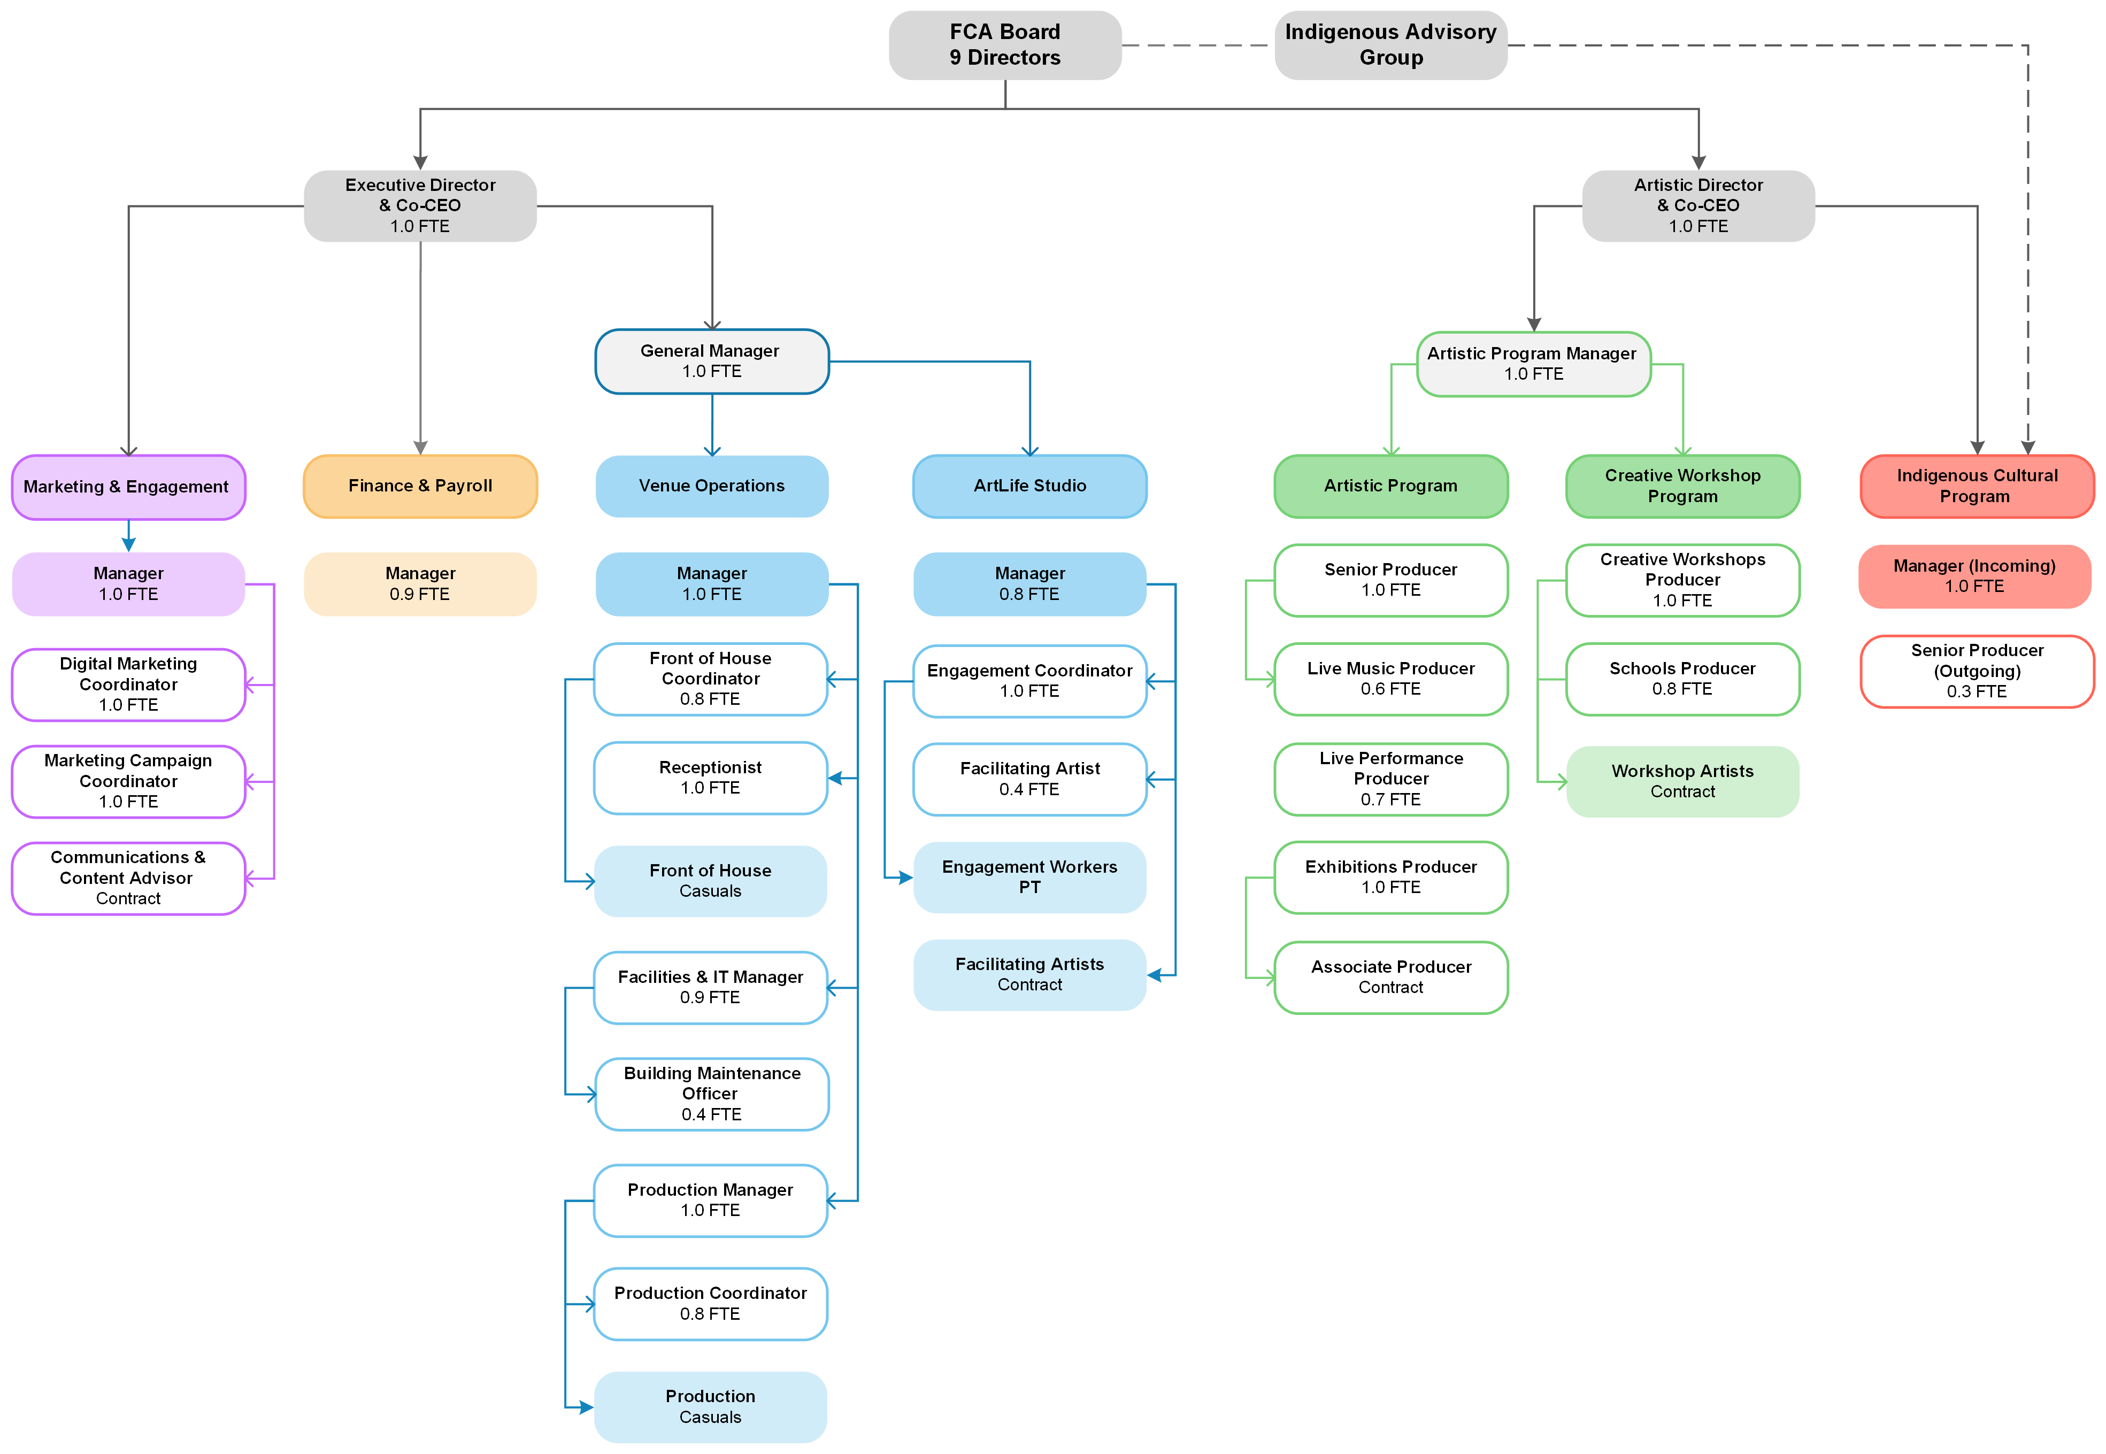
Our Team Structure

