The Dreaming Project Accessibility Overview

This outdoor performance will take place around the grounds of Footscray Community Arts (FCA) It is a travelling performance with seating in the amphitheatre at the end. It starts at 8.15pm and ends at 9.45pm.
Please note that the path of the show is flat and downhill therefore the return journey will be uphill. An option to avoid the uphill journey at the end would be to get picked up by a vehicle from Maribyrnong St.
The path does not include any steps. The information and photos that follow should help people decide if it will be suitable for your access needs.

There will be six stopping sites:
Stop 1. FCA front lawn, upper level of Henderson House – Box Office check in and first part of show - 30 minute duration
Travel 30 metres along concrete
Stop 2. South Car Park – 10 minute duration
Travel 60m along concrete
Stop 3. Rear of Henderson House – 15 minute duration
Travel 20 metres on concrete path then 70 metres along compacted gravel path
Stop 4. Rose Garden – 15 minute duration
Travel 30 metres on gravel path then 45 metres along bitumen path by the river
Stop 5. Stone archway – 5 minute duration
Travel 15 metres along bitumen path, up accessible ramp (or two steps) onto grass. Then travel 10 metres on grass to seating. There are places in the front row for people using wheelchairs and other mobility aids.
Stop 6. Final stop, Amphitheatre (bluestone and grass seating available for all) – 15 minute duration
End of Show. Audience can leave amphitheatre following the same path back up to the front lawn.
Those able to walk up blue stone steps can rejoin the gravel path at the top of the amphitheatre to get back to the concrete path.
Photography is not permitted during the show. Some projections will be left on and audience are invited to take photos as you follow the path back up to the front lawn.
Front of House (FOH) staff can provide basic folding chairs or backless metal stools at the first four stopping sites for audience who need them. Please identify your needs to Box Office Staff on arrival. You can bring your own folding chair along if you want to.
There are toilets including an accessible toilet, inside Henderson House near the Box Office.
You may also call FCA before booking a ticket if you would like to discuss your access needs. 03 9362 8888

Please note that the following photos have been taken in daylight. It will be dusk at 8.15pm when the show begins and night time when it finishes. Travelling paths will be lit with festoon lights rigged overhead at the front of Henderson House and at 1m high along the rest of the path.
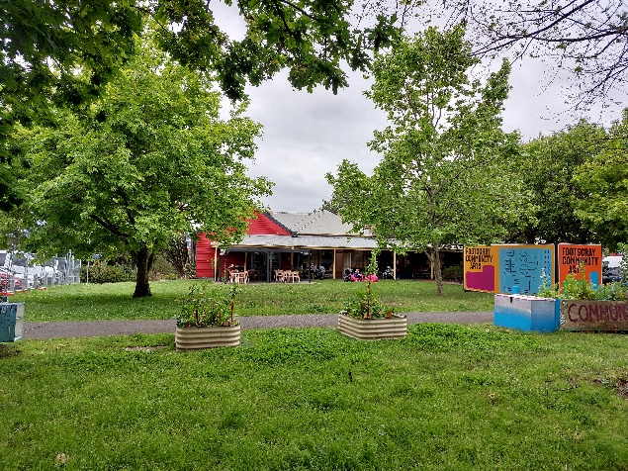
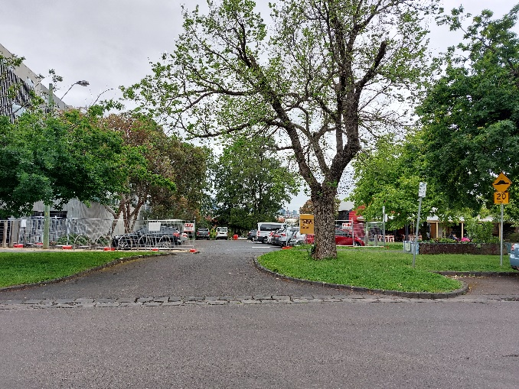
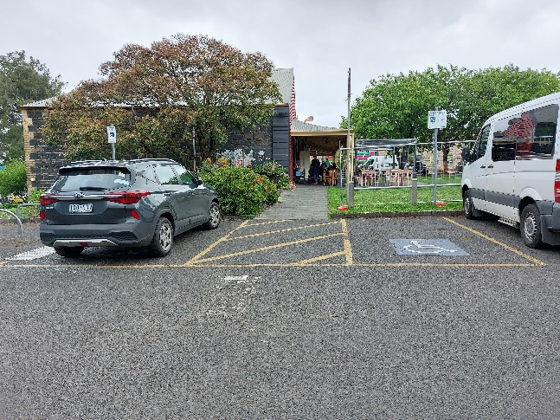
FCA from Moreland St FCA Public carpark (North)
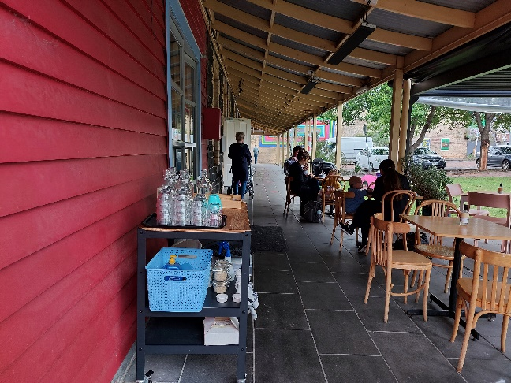
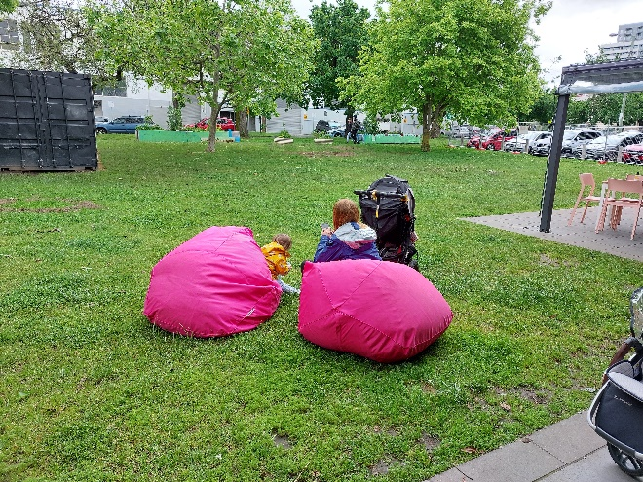
2 x access parks. South carpark will be closed. Box Office will be set up where the chairs are.
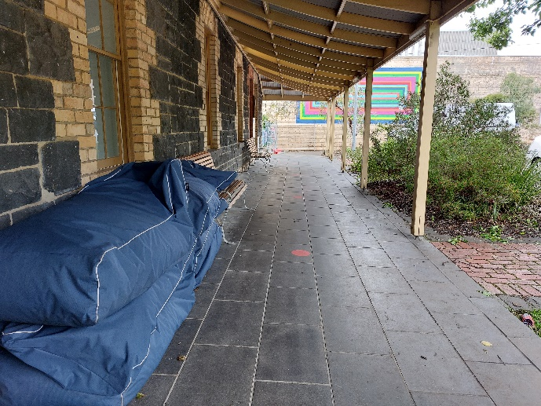
The show will start on this front lawn. Stop 1 Travel path to Stop 2 at end of path
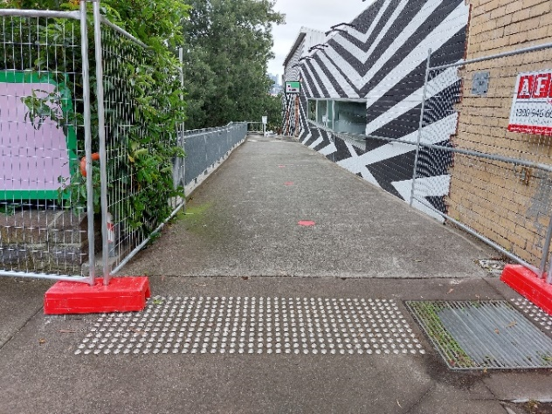
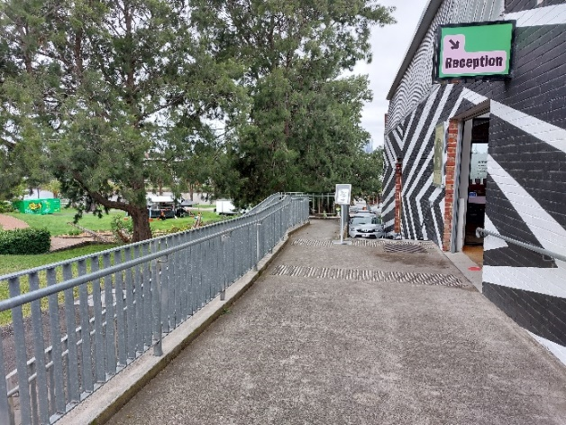
Travel path. Temporary fence won’t be there. Travel path continues.
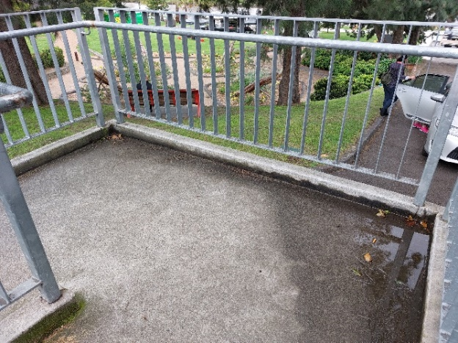
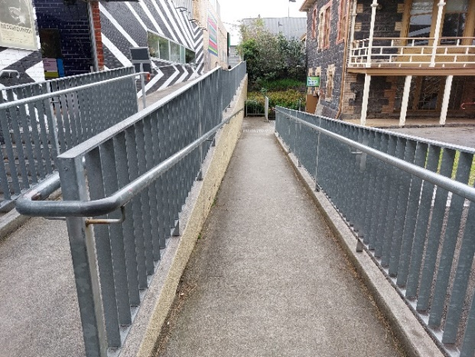
Ramp width 1200mm + 1300mm - 1800mm on turn Ramp continues 1200mm width
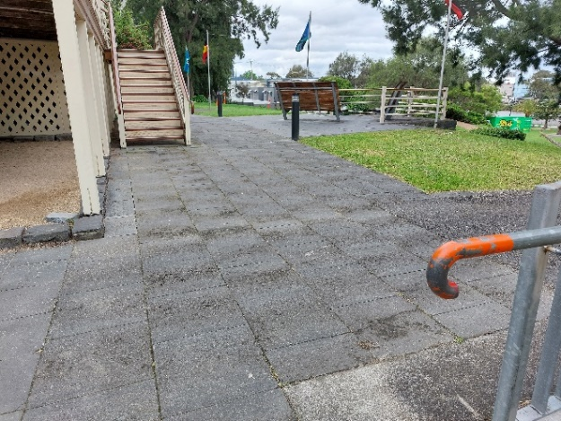
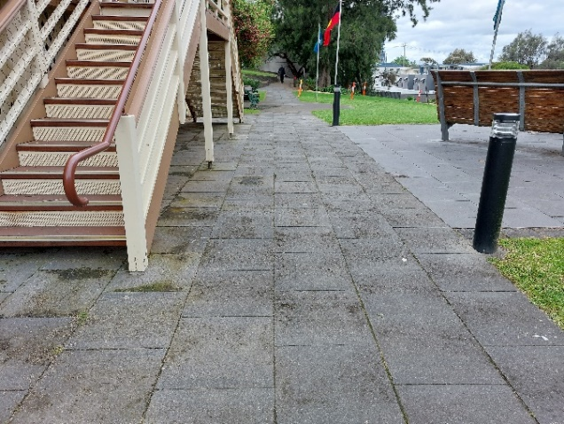
Gathering point for Stop 3 Concrete travel path
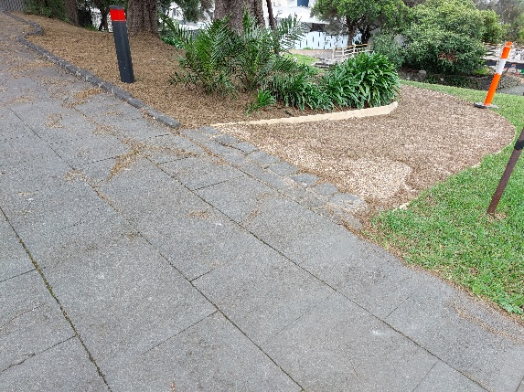
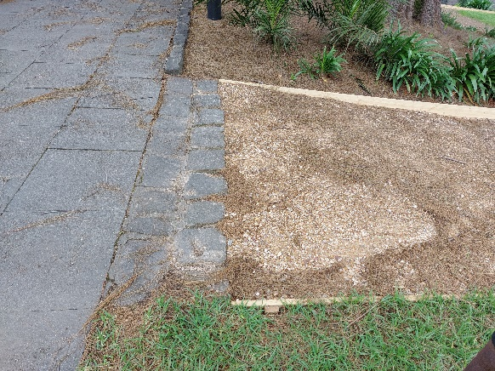
Start of compacted gravel path
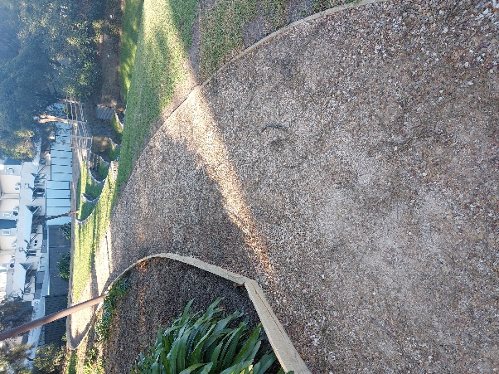
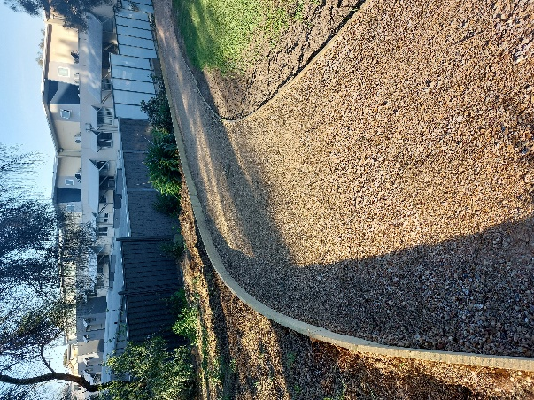 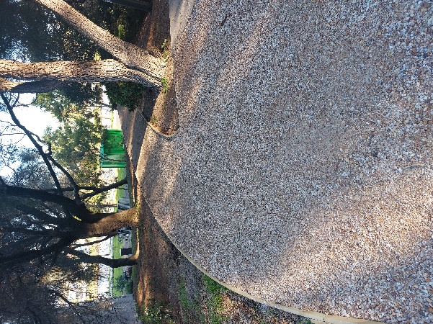
Compacted gravel path continues
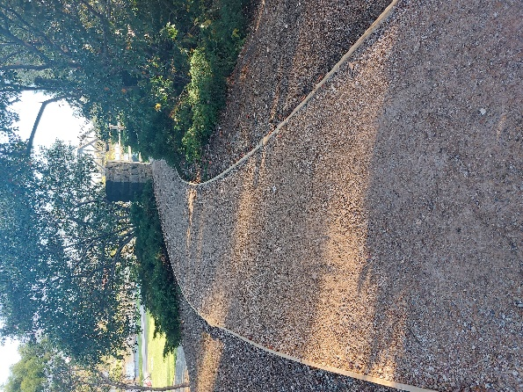
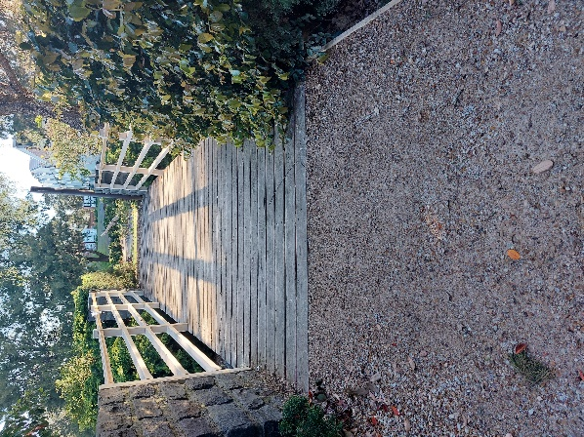 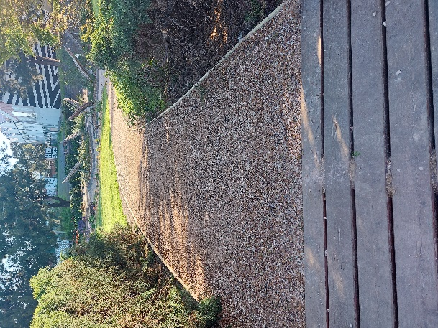
Path continues to a wooden bridge across the amphitheatre
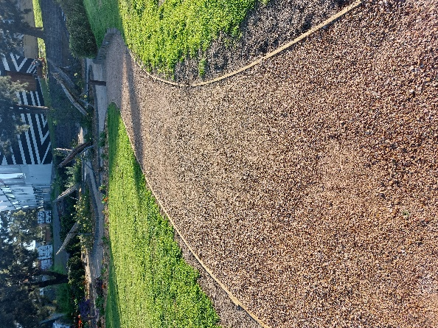
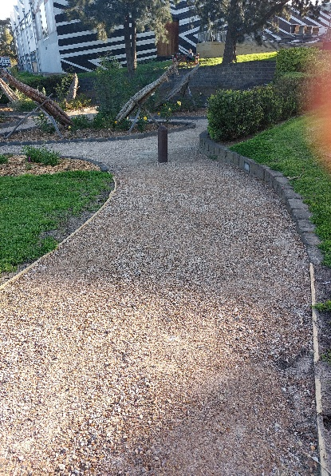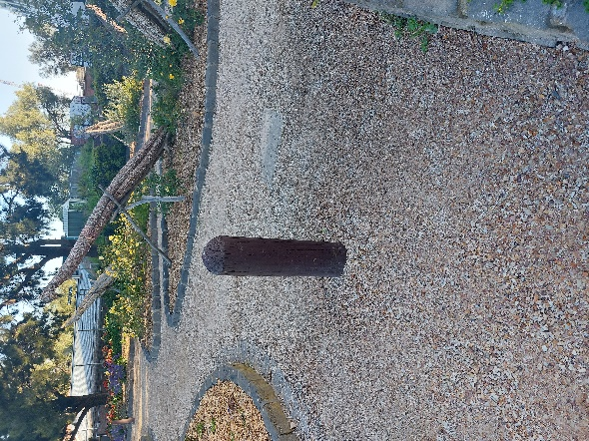
Path continues to Stop 4 – the Rose garden. Path turns to the left. 1.23m distance to left of the bollard.

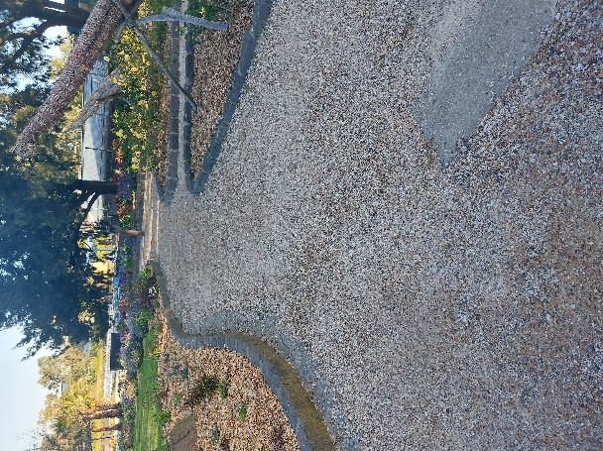
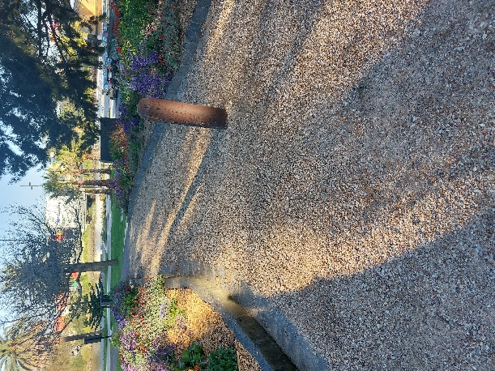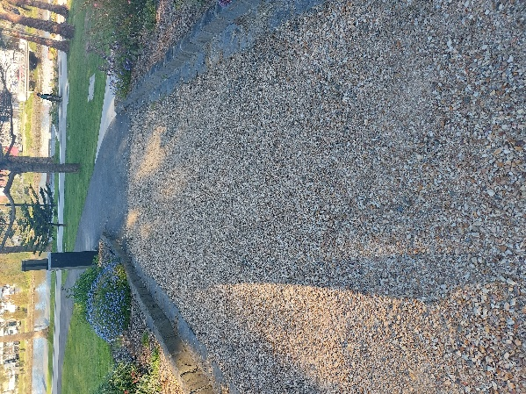
Path continues past rose garden. Next bollard has 1.4m gap on left. Bitumen path starts
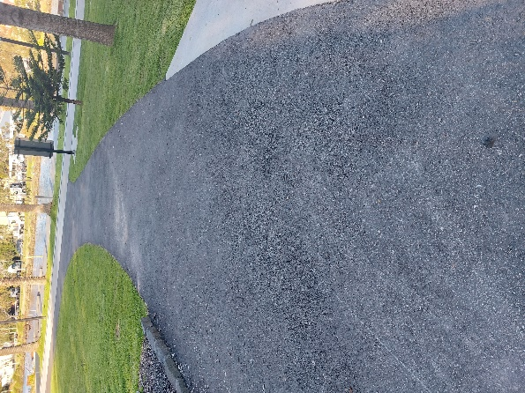 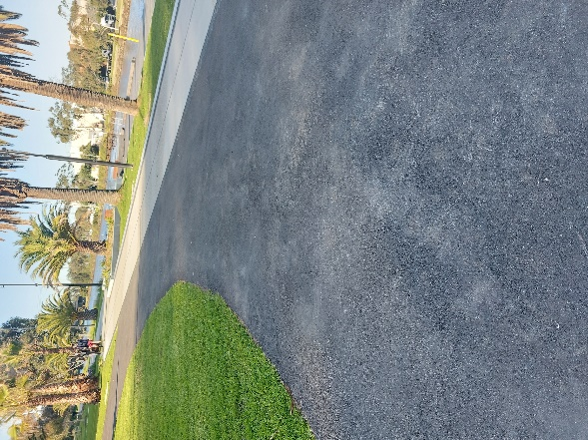 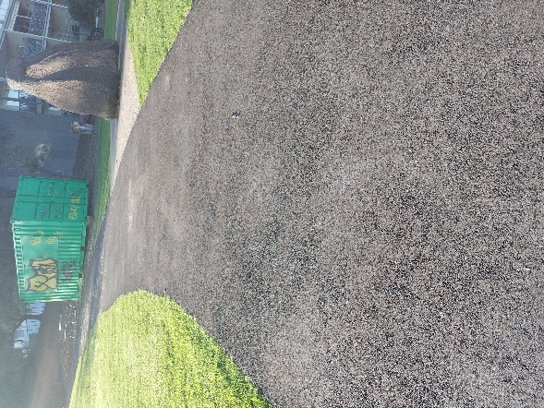
Bitumen path continues around past the river to Stop 5 stop at the stone archway.
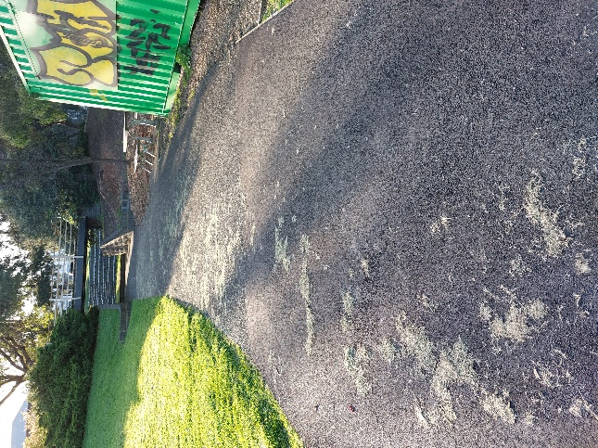
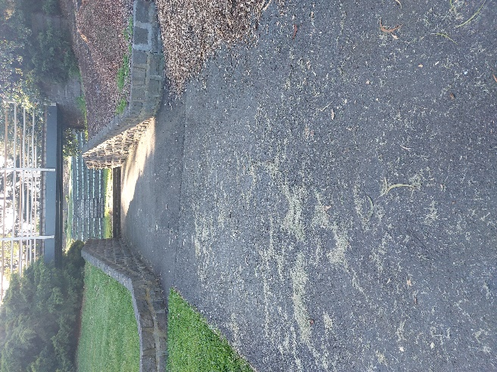
From the stone archway the path continues to the amphitheatre
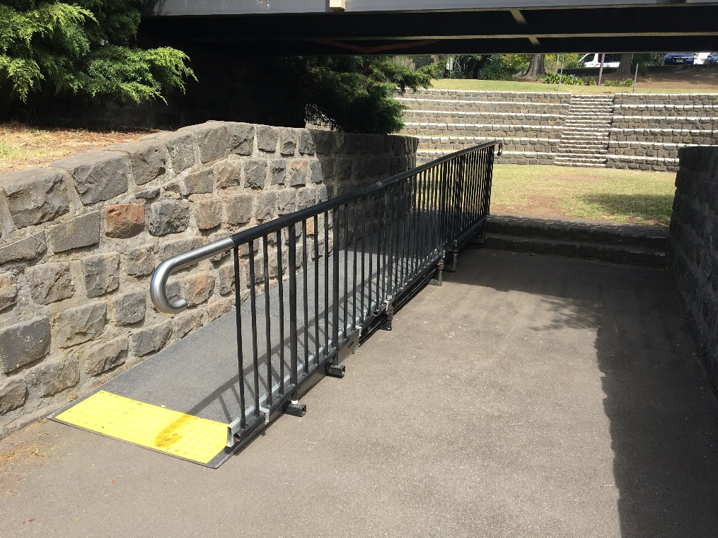
There will be a ramp installed across the 2 steps.
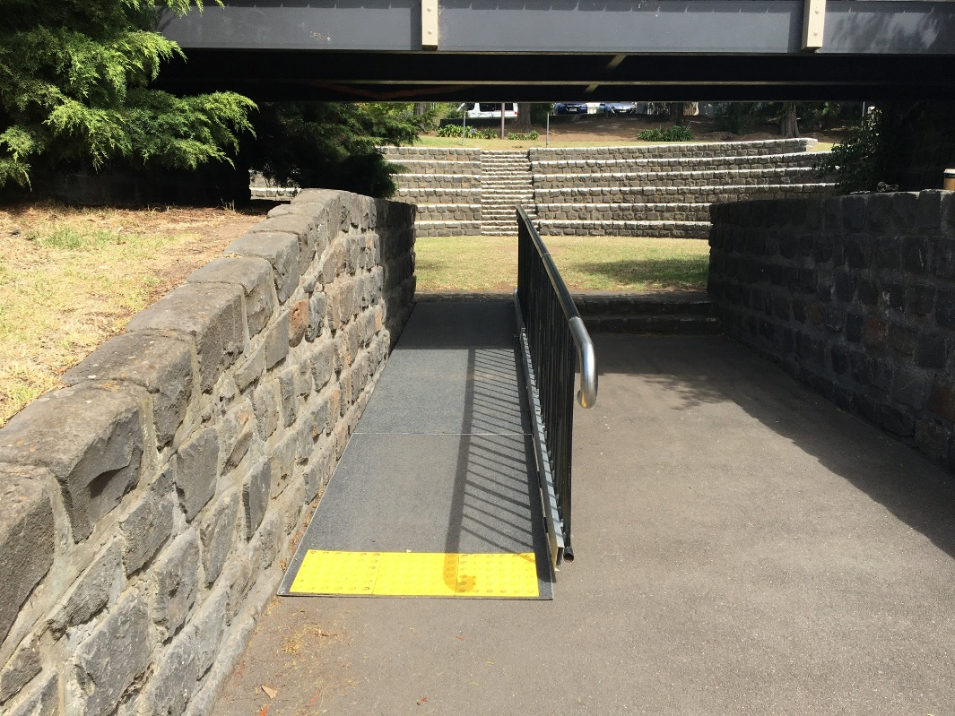
Once in the amphitheatre travel will be across grass to seating.

