Community Feedback Day Access Information

When: 10am—1pm, 5 November 2022
Where: Footscray Community Arts 45 Moreland Street Footscray 3011
Venue: Warehouse building, main foyer and performance space

Accessibility and support at this event:

- Auslan Interpreter
- Audio description service
- Taxi drop off/pick up assistance + booking cab
- Service dogs are welcome
- Wheelchair charging area in foyer
- Support making tea or coffee and getting something to eat.
- Photography – there will be a photographer present who will ask for consent

If you have any further access requirements not listed in this information pack please contact reception. 03 9362 8888 or reception@footscrayarts.com

Optional supports available

Please contact reception to book the following options:
- A support person to walk from Footscray Station to Footscray Community Arts and/or do the return walk with you. Support is available from the station to Footscray Community Arts at 10:30am. We can support you to return to Footscray station at a time of your choosing.
- A friendly Footscray Community Art staff member to welcome you at Footscray Community Arts at your specified arrival time.

What to expect

When you arrive
You will be welcomed at the front of the warehouse building, by our staff who will be wearing Footscray Community Arts T-shirts and hi-vis shirts. We will be supporting taxi drop off and pick up and can guide you to the reception area.

Navigating the day
When you arrive in the foyer at the reception area, Footscray Community Arts staff are available to direct or guide you through the space. There will be a feedback station in the performance space, food and drinks, quiet room and the Visual Arts Studio space with a display of art from our ArtLife community.

Giving Feedback

Group discussion: 11am, Performance Space
Our staff will facilitate a group discussion, using questions as a guide to receive your feedback. You can choose to participate or observe.
Group questions will include:
- What do you think Footscray Community Arts could improve in terms of accessibility?
- What do you think Footscray Community Arts does well in terms of accessibility?

Interactive Feedback Station, Performance Space
There will be three staff members available to receive and support you to give feedback at our feedback station. The feedback station will be open from 10am—1pm. You can drop in any time and provide feedback in a number of different ways:
- You can write/ draw on feedback posters.
- Verbally, we can write your feedback for you.
- You can point to symbols to communicate your feedback.
- You can meet with us one on one and chat about your experience.
- Our wider survey will also be available to fill out on an iPad and on paper.

Food & Drinks
The following food and drinks will be available at the Feedback Community Day.
- A sausage sizzle will be located at the front of Footscray Community Arts, providing sausages (meat and vegetarian options available, wheat and gluten-free bread).
- Catering will be available in the Footscray Community Arts foyer on a large table. It will have sandwiches and quiches. Vegetarian, gluten and dairy free options will be available.
- Tea, coffee and cold drinks (non-alcoholic) will be available in the Footscray Community Arts foyer.

Art Display (ArtLife & Visual Arts Studio)
- Artwork by ArtLife artists will be on display.
- Footscray Community Arts staff can guide you through the artwork and answer questions about our ArtLife program.
- Visual description of the work is available.

Quiet Space
In the Jack Kennedy room, by the foyer we will have a quiet room.
- The room will have dim lighting.
- There will be chairs, bean bags and cushions.
- Headphones and iPads available to listen to music & chill out to.

Getting to Footscray Community Arts

Footscray Community Arts is located on the banks of the Maribyrnong River and can be accessed by public transport and car.

To get to Footscray Community Arts by public transport, catch the train to Footscray Station. Footscray Community Arts is approximately 500 metres away from the station down Bunbury Street (accessed from platform 4). Please note that this street has four road crossings, all with pedestrian lines and one with pedestrian light-controlled crossing. This street has uneven concrete on the footpath.

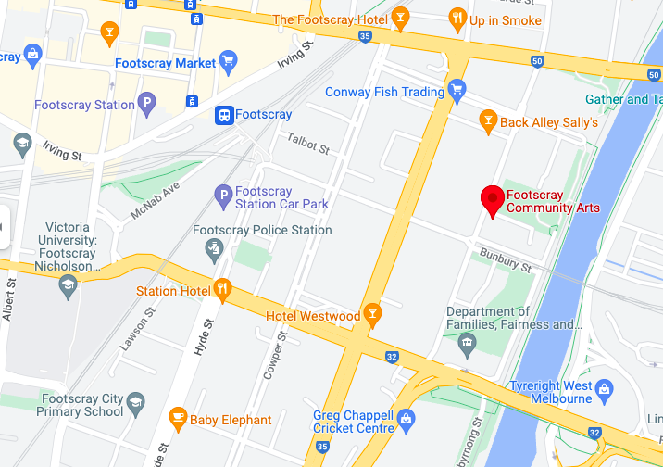
Image Description: A Google map of Footscray, showing Footscray Community Arts with a red pin.

Footscray Community Arts Entrance
Accessible parking and a taxi/drop off area are located on the Moreland Street side of Footscray Community Arts, approximately twenty metres from the main warehouse building and foyer/reception area.

This is an image of Footscray Community Arts Moreland Street entrance and car park.
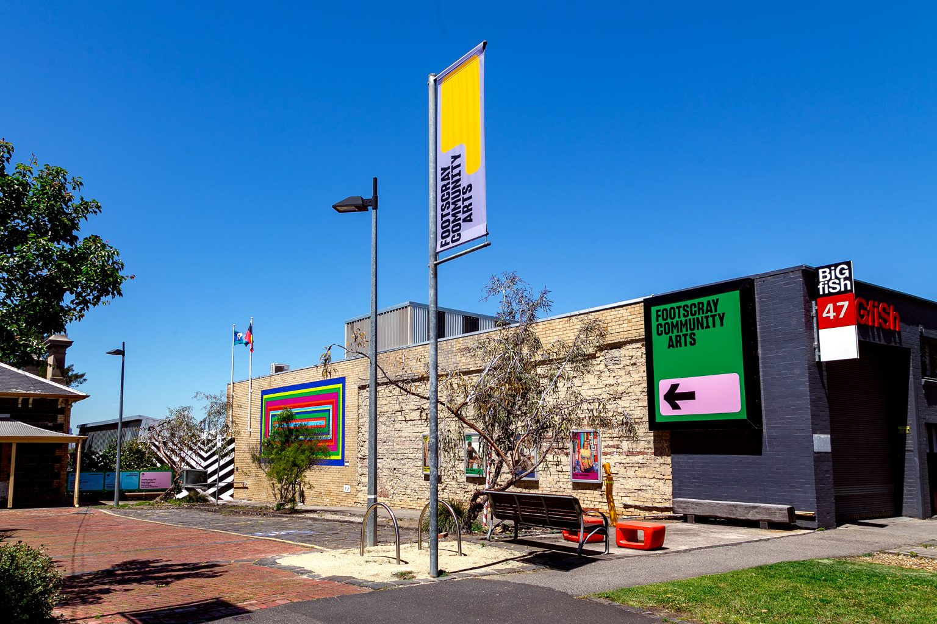

Map of Footscray Community Arts

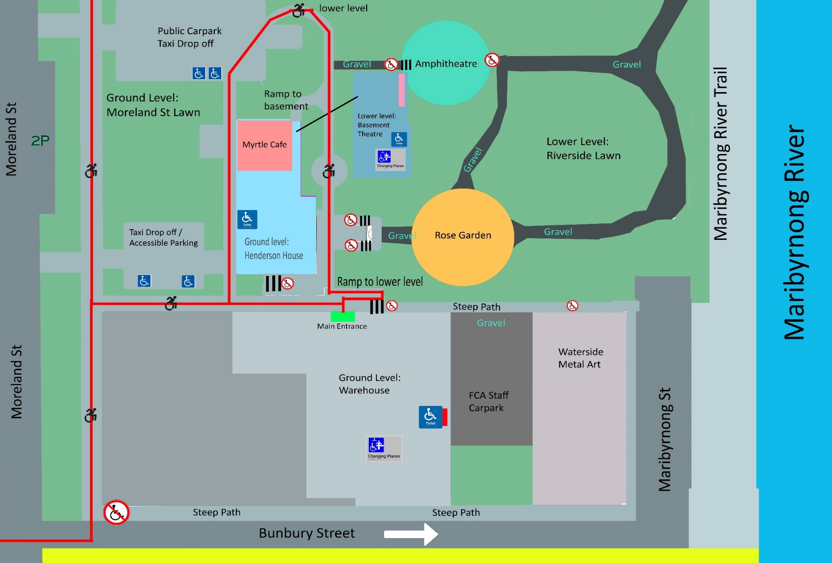
This is an illustrated map of Footscray Community Arts precinct. Red lines highlight wheelchair accessible pathways across our precinct. There are two accessible parks in each carpark area. Taxi drop off area is in each car park. All internal venues are wheelchair accessible. The warehouse building has one accessible toilet.

